Government of Pakistan

National Vocational and Technical Training Commission

Prime Minister’s Hunarmand Pakistan Program

"Skills for All"



Course Contents / Lesson Plan
Course Title: Artificial Intelligence (Machine Learning & Deep Learning)
Duration: 3 Months

Trainer Name
Course Title | Artificial Intelligence (Machine Learning & Deep Learning)
Objective of Course | Employable skills and hands on practice for Artificial Intelligence, including specialization in Natural Language Processing (NLP) and Microsoft Azure AI Associate  The aim for the team of staff responsible for delivery of the advanced IT curriculum is to provide knowledge and develop skills related to the IT. The course will allow participants to gain a comprehensive understanding of all the aspects. It will also develop the participant’s ability to act in a professional and responsible manner.  Teaching staff will provide the technical knowledge and abilities required to solve tasks and problems that are goal-oriented. They will use participant-centered, practically oriented methods. They will also develop a program of practical assessment that reflects the learning outcomes stated in the curriculum. Trainees of the IT curriculum will also develop their willingness and ability as individuals to clarify issues, as well as think through and assess development opportunities.  Teaching staff will also support trainees in developing characteristics such as self-reliance, reliability, responsibility, a sense of duty and a willingness and ability to criticize and accept criticism well and to adapt their future behavior accordingly.  Teaching staff also use the IT curriculum to address the development of professional competence. Trainees will acquire the ability to work in a professional environment. By the end of this course, the trainees should gain the following competencies:  Understanding of core concepts of artificial intelligence and machine learning  State of the art machine learning techniques Hands-on exposure to exploratory data analysis Practical exposure to model design, evaluation  Familiarity with tools and libraries such as scikit learn, pandas numpy, tensorflow, pytorch and keras

Learning Outcome of the Course | After taking this course, you will be familiar with the fundamentals of Artificial Intelligence. You will gain practical experience in applying AI for problem solving, and will develop a deep understanding of the core concepts by implementing solutions to real world problems.  By the end of this course, the trainees should gain the following competencies:  Understanding of core concepts of artificial intelligence and machine learning  State of the art machine learning techniques Hands-on exposure to exploratory data analysis Practical exposure to model design, evaluation  Familiarity with tools and libraries such as scikit learn, pandas numpy, tensorflow, pytorch and keras  After the specialization in NLP, you will be comfortable using TensorFlow pipelines for NLP at the end of the course. Moreover, You will learn to build your own models which will extract information from textual data. You will learn text processing fundamentals, including text normalization, stemming and lemmatization. You will learn about different evaluation metrics for models trained for NLP tasks. You will learn to make a part of speech (POS) tagging model. You will learn about named entity recognition. You will learn advanced techniques including word embeddings, deep learning (DL) techniques. You will learn how to deploy a NLP model  Moreover, you will learn not only all these skills but also learn to use Microsoft Azure API for Machine and Deep Learning for numerical, image and text data.
Student entry level | Bachelor in IT/ CS/ Maths/Statistics/Economics/Physics or Bachelor of Engineering or 5th Semester students enrolled in HEC approved degree program in IT/CS/MIS/Stats/Maths
Teacher eligibility Criteria | Bachelor in Computer Science/IT/SE/EEE/AI or a related field having 3 years expertise machine learning/ deep learning/ natural language processing/ proven industry experience in AI applications.
Course Execution Plan | Total Duration of Course: 3 Months
 | Class Hours: 4 Hours per day
 | Theory: 20% Practical: 80%
Companies Offering Jobs in the respective trade | - Careem  - Afiniti  - Addo.ai  - Arbisoft  - I2c  - Xavor  - Fiverivers Technologies  - Confiz  - Crossover  - NetSol  - Research institutes  - All Private Institutes who have an ML department
Job Opportunities | AI is the buzzword of the century, attracting attention across industries, motivating changes in products as well as services. It  is the very nature of the subject that makes its applications infinite,

in multiple domains. Whether you belong to a technical background or not, chances are that AI can make your job easier, and push it in the right direction. Dive in to develop an understanding of the core concepts, while gaining hands on experience and training from the industry’s finest. Trained resources can find work as one of the following roles:

- AI Associate Engineer
- Machine Learning associate analyst
- Assistant Data Analyst
- Research Assistant

No of Students | 25
Learning Place | Classroom / Lab
Instructional Resources  / Reference Material | Linux:  - Learn Linux Shell Scripting – Fundamentals of Bash 4.4  [Sebastiaan Tammer - Packt Publishing Ltd.]  - Sams Teach Yourself Shell Programming in 24 Hours  [Second Edition , Sams Publishing]  - Applied Data Science – (Chapter 01) [Ian Langmore & Daniel Krasner]  - Linux Tutorial – Basic Command Line https://www.youtube.com/watch?v=cBokz0LTizk  Python:  - Learning Python – 2nd Edition (Ch:12: OOP in Python)  [B. Nagesh Rao, CyberPlus Infotech Pvt. Ltd.]  - Python for Everybody  [Dr. Charles R. Severance]  - Python: A Simple Tutorial  [Matt Huenerfauth, University of Pennsulvania, USA]  - Smarter Way to Learn Python [Mark Mayers]  - A Python Book: Beginning Python, Advanced Python, and Python Exercises  [Dave Kuhlman]  - Mastering Object-Oriented Python  [Second Edition, Steven F. Lott, Pack Publishing Ltd.]  - Python Official Documentation https://docs.python.org/3/  Descriptive Statistics and Probability:  - Probability for Machine Learning [Jason Brownlee]  - Making Sense of Data: A Practical Guide to Exploratory Data Analysis and Data Mining (Ch: 02) [Second Edition, Glenn J. Myatt & Wayne P. Johnson, WILEY]  - Practical Statistics for Data Scientists  [Second Edition, Peter Bruce, Andrew Bruce, and Peter Gedeck, O’REILLY]

Exploratory Data Analysis:
- Numpy
  - Python for Data Analysis
(Ch:04, Appendix A: Advanced Numpy) [Second Edition, Wes McKinney, O’REILLY]
  - Numpy Official Documentation https://numpy.org/doc/1.24/
- Pandas
  - Pandas 1.x Cookbook
[Second Edition, Matt Harrison & Theodore Petrou, Pack Publishing Ltd.]
  - Python for Data Analysis (Ch:05, 07, 10, 12)
[Second Edition, Wes McKinney, O’REILLY]
  - Hands-on Exploratory Data Analysis with Python
(Ch: 04, 06)
[Suresh Kumar Mukhiya & Usman Ahmed, Pack Publishing Ltd.]
  - Pandas Official Documentation https://pandas.pydata.org/docs/
- Matplotlib
  - Pandas 1.x Cookbook (Ch:13)
[Second Edition, Matt Harrison & Theodore Petrou, Pack Publishing Ltd.]
  - Hands-on Exploratory Data Analysis with Python
(Ch: 04, 06)
[Suresh Kumar Mukhiya & Usman Ahmed, Pack Publishing Ltd.]
  - Matplotlib Official Documentation https://matplotlib.org/stable/index.html
- Seaborn
  - Pandas 1.x Cookbook (Ch:13)
[Second Edition, Matt Harrison & Theodore Petrou, Pack Publishing Ltd.]
  - Python for Data Analysis (Ch:09)
[Second Edition, Wes McKinney, O’REILLY]
  - Seaborn Official Documentation https://seaborn.pydata.org/

Machine Learning:
- Machine Learning by Andrew NG (Also available freely on Youtube) https://www.coursera.org/collections/machine- learning
- Machine Learning: An Algorithmic Perspective [Second Edition, Stephen Marsland, CRC Press]
- Hands-On Machine Learning with Scikit-Learn,
Keras, and TensorFlow
[Third Edition, Aurélien Géron, O’REILLY]
- XGBoost with Python [Jason Brownlee]
- Learn TensorFlow 2.0
[Pramod Singh & Avinash Manure, Apress]

Natural Language Processing:
- Speech and Language Processing
- [Third Edition, Dan Jurafsky, James H. Martin]
- Deep Learning for Natural Language Processing [Jason Brownlee]
- Natural Language Processing Cookbook
[Krishna Bhavsar, Naresh Kumar, & Pratap Dangeti, Pack Publishing Ltd.]

Deep Learning:
- Deep Learning by Andrew NG (Also available freely on Youtube)
- https://www.coursera.org/learn/neural-networks- deep-learning
- Deep Learning with Python [Jason Brownlee]
- Deep Learning for Time Series Forecasting [Jason Brownlee]
- Long Short-Term Memory Networks with Python [Jason Brownlee]
- [Jason Brownlee]
- Dive into Deep Learning
[Aston Zhang, Zachary C. Lipton, Mu Li, and Alexander J. Smola]
Microsoft Azure Machine Learning:
- Mastering Azure Machine Learning: Execute Large- Scale End-to-end Machine Learning with Azure [Second Edition, Christopher Korner and Marcel Alsdorf, Packt Publishing Ltd.]
- Microsoft Azure AI Fundamentals Training

https://learn.microsoft.com/en- us/training/paths/prepare-teach-ai-900- fundamentals-academic-programs/
- Microsoft Azure AI Associate Training https://learn.microsoft.com/en- us/training/paths/prepare-teach-ai-102-microsoft- design-implement-azure/
- Microsoft Learn for Educators Program https://learn.microsoft.com/en-us/training/educator- center/programs/msle/
Software Download:
- Anaconda https://www.anaconda.com/
- VSCode https://code.visualstudio.com/
- PyCharm (Community Edition) https://www.jetbrains.com/pycharm/
- PyTorch
https://pytorch.org/get-started/locally/
- TensorFlow 2.0 https://www.tensorflow.org/install

Schedule d Week | Module Title |  |  | Learning Units | Remarks
Week 1 | Introduction  Linux Shell Scripting Fundamentals  Python Fundamentals | Day 1 | Hour# 1 | - Introduction to AI  - Motivational Lecture (For further detail please see Page No: 3& 4) | - Task 1  - Task 2  - Task 3-25  Details may be seen at Annexure-I
 |  |  | Hour# 2 | - Course Introduction  - Job market  - Course Applications  - Work ethics  - Survey of career opportunities  - Survey of industry requirements for each career path  - ​
 |  |  | Hour#  3, 4 | - Software Installation (Anaconda, VSCode, PyCharm, etc.)
 |  | Day 2 | Hour# 1 | Introduction to Debian  - Basic Commands: pwd, cd, ls, cat, sudo, man, redirection, mkdir, rm, rmdir, cp, mv
 |  |  | Hour#  2 | - file, reading, cat, more, less, head, alias,
 |  |  | Hour#  3 | - shutdown, restart, touch, nano, bash, sh, chmod, ps, kill, dpkg
 |  |  | Hour#  4 | - Package update and upgrade  - Environment Variables
 |  | Day 3 | Hour #  1 | Values, expressions, and statements  - Numbers, Booleans, Strings  - Operators, variables and keywords
 |  |  | Hour  # 2,3 | - String operations
 |  |  | Hour #  4 | - Input and Type casting  - Comments
 |  | Day 4 | Hour #  1 & 2 | Data Structures  - Lists  - Tuples
 |  |  | Hour #  3 & 4 | - Dictionaries  - Sets
 |  | Day 5 | Hour #  1 & 2 | Conditional Execution  - If, elif, and else statements  - Break, continue, and pass statements

- Nested conditionals
- Conditional (Ternary) Expression
 |  |  | Hour #  3 & 4 | - While, for loops and use of enumerate  - Nested loops  - List comprehension  - Iterators and Iterables  - ​
Week 2 | Python Fundamentals  Implementation of OOP Principals in Python  Descriptive Statistics and Probability | Day 1 | Hour# 1 | - Motivational Lecture (For further detail please see Page No: 3& 4) | - Task 26-  27  - Task 49-  51  Details may be seen at Annexure-I
 |  |  | Hour# 2, 3 | - Functions  - Functions and variable scope  - Lambda expression  - Map and Filter  - Inner/Nested functions
 |  |  | Hour #  4 | - File Handling  - Exception Handling
 |  | Day 2 | Hour# 1 | - Classes and Objects  - Instance Variables and Methods  - Class Variables and Functions  - Constructors and Destructors
 |  |  | Hour# 2,3 | - Inheritance  - Multilevel Inheritance  - Hierarchical Inheritance  - Multiple Inheritance, Method Resolution Order
 |  |  | Hour# 4 | - Access Specifiers: Private, Public, Protected  - Name Mangling  - Inner/Nested Class  - Association, Aggregation, Composition
 |  | Day 3 | Hour#  1 | - Polymorphism and Operator Overloading
 |  |  | Hour# 2 | - Magic Functions/Dunder Functions
 |  |  | Hour# 3 | - Dynamic Polymorphism (subclass as base class)
 |  |  | Hour# 4 | - Abstract Method and Class, Empty Class, Data Class  - Keyword Arguments
 |  | Day 4 | Hour# 1, 2 | - Data and its types (structured, Unstructured)  - Quantitative data, Numerical, Continuous, and Discrete variables

 | Overview |  |  | - Qualitative data, Categorical, Nominal, Ordinal, and Binary variables
 |  |  | Hour #  3-4 | Measures of Central Tendency  - Mean, Mode, Median
 |  | Day 5 | Hour# 1,2 | Measures of Dispersion  - Variance, Standard deviation  - Co-efficient of variation, skewness and kurtosis
 |  |  | Hour# 3, 4 | Measures of Position  - Z-Score, Percentile, Quartile
Week 3 | Descriptive Statistics and Probability Overview  Python Support Libraries for Exploratory Data Analysis  - NUMPY | Day 1 | Hour# 1 | - Motivational Lecture (For further detail please see Page No: 3& 4) | - Task 28-  48  Details may be seen at Annexure-I
 |  |  | Hour#  2 | - Correlation Coefficient
 |  |  | Hour# 3 | - Univariate, bivariate and multivariate plots
 |  |  | Hour# 4 | Probability
 |  | Day 2 | Hour# 1 | Joint, Marginal and Conditional probability
 |  |  | Hour# 2 | - Probability Distributions  - ​
 |  |  | Hour # 3-4 | - Discrete and Continuous probability distributions  - Bayesian Probability
 |  | Day 3 | Hour# 1 | - Introduction to Numpy
 |  |  | Hour# 2,3,4 | - Creating Numpy Arrays (from Python list, from built-in methods, from random)  - Array Attributes and Methods (reshape, max,  min, argmax, argmin, shape, dtype, size, ndim)  - Operations on Arrays (copying, append and  Insert, Sorting, Removing/Deleting, Combining/Concatenating, Splitting)
 |  | Day 4 | Hour # 1-2 | - Data Loading & Saving  - NumPy Indexing and Selection (Indexing a 2D array, Logical Selection)  - Broadcasting
 |  |  | Hour # 3-4 | - Type Casting  - Arthmetic Operations (Add, Subtract, Multiply, Divide, Exponentiation)  - Universal Array Functions (sqrt, exp, max,

 | - Pandas |  |  | sin, etc)
 |  | Day 5 | Hour#  1 | - Introduction to Pandas
 |  |  | Hour# 2 | - Series and DataFrame and Data Input  - Selection and Indexing (rows, columns, conditional selection, selection of subset of rows and columns, index setting, etc)
 |  |  | Hour# 3 | - Operations on DataFrames (head, unique, value counts, applying custom functions, getting column and index names, sorting and  ordering, null value check, value replacement, dropping rows and columns, etc)
 |  |  | Hour#  4 | - Missing data & its handling
Week 4 | Python Support Libraries for Exploratory Data Analysis  - Pandas  - Seaborn | Day 1 | Hour# 1 | - Motivational Lecture (For further detail please see Page No: 3& 4) | - Task 28-48  Details may be
 |  |  | Hour# 2 | - Merging, Joining, and Concatenation (inner,  outer, right and left joins)
 |  |  | Hour # 3-4 | - GroupBy  - Discretization and Binning  - Operations on DataFrames  - Data output/saving  - Pandas for Plotting (area, bar, density, hist,  line, scatter, barh, box, hexbin, kde, and pie plots
 |  | Day 2 | Hour# 1 | - Introduction to Seaborn | seen at  Annexure-I
 |  |  | Hour# 2 | Distribution Plots  - distplot  - jointplot (pairplot, rugplot, kdeplot)
 |  |  | Hour# 3 | Categorical Data Plots  - factorplot, boxplot, violinplot, stripplot, swarmplot, barplot, countplot
 |  |  | Hour# 4 | Matrix Plots  - Heatmap
 |  | Day 3 | Hour# 1 | - Machine learning introduction and types
 |  |  | Hour# 2,3,4 | - Classical machine learning pipeline (data collection, preprocessing, feature crafting,  modeling, testing and evaluation, and deployment)
 |  | Day 4 | Hour # 1,2 | - Supervised machine learning  - Regression and classification problems  - Components of supervised machine learning (labeled data, hypothesis, cost function,  optimizer)
 |  |  | Hour  # 3,4 | - Univariate Linear Regression with Gradient Descent

 |  | Day 5 | Hour # 1-2 | - Univariate Linear Regression with Gradient Descent  - Without Vectorization
 |  |  | Hour # 3-4 | - With Vectorization
Week 5 | Machine Learning-I | Day 1 | Hour# 1 | - Motivational Lecture (For further detail please see Page No: 3& 4) | - Task – 51,52  Details may be seen at Annexure-I
 |  |  | Hour#  2,3,4 | - Multivariate Linear Regression
 |  | Day 2 | Hour# 1,2,3,  4 | - Polynomial Regression
 |  | Day 3 | Hour# 1,2,3,  4 | - Logistic Regression (Binary Classification)
 |  | Day 4 | Hour# 1,2,3,  4 | - Logistic Regression (Multiclass Classification)
 |  | Day 5 | Hour# 1,2,3,  4 | - Code practice
Week 6 | Natural Language Processing | Day 1 | Hour# 1 | - Motivational Lecture (For further detail please see Page No: 3& 4) | - Task 53-  55  Details may be
 |  |  | Hour#  2 | - Introduction to Natural Language Processing
 |  |  | Hour# 3 | - Syntax, Semantics, Pragmatics, and Discourse  - NLP curves and future directions
 |  |  | Hour# 4 | Data pre-processing for NLP  - Introduction to NLTK/SpaCy  - Noise removal (stopwords, punctuation, etc)
 |  | Day 2 | Hour# 1 | - Word and sentence tokenization  - Word segmentation  - Stemming  - Text normalization  - Regular expression for string parsing | seen at  Annexure-I
 |  |  | Hour # 2-3 | - POS tagging  - NER tagging  - Chunking and Chinking  - Lemmatization  - WordNet
 |  |  | Hour# 4 | - Words as features (BoW model)  - Feature Selection and Extraction  - Document Similarity
 | Machine Learning II | Day 3 | Hour# 1 | - Testing
 |  |  | Hour# 2 | - Evaluation Metrics  - Classification and Regression

 |  |  | Hour # 3-4 | - Dataset imbalance and its remedies (Augmentation)
 |  | Day 4 | Hour# 1,2,3 | - Support Vector Machine (SVM)
 |  |  | Hour#  4 | - Decision Tree
 |  | Day 5 | Hour# 1,2 | - Decision Tree
 |  |  | Hour  # 3-4 | - Bagging – Random Forest
Build Your CV – Mid-term Exam
Week 7 | Deep Learning I | Day 1 | Hour# 1 | - Motivational Lecture (For further detail please see Page No: 3& 4) | - Task 56-64  Details may be seen at Annexure-I
 |  |  | Hour# 2,3,4 | - Boosting
 |  | Day 2 | Hour# 1,2,3,  4 | MLP Feed Forward Neural Network  - Forward and backward passes  - Nonlinearity: Activation functions  - Cross-Entropy  - Computational graph and Backpropagation  - Vanishing and exploding gradients  - Overfitting, underfitting, dropout regularization
 |  | Day 3 | Hour# 1,2,3,  4 | - Introduction and implementation of neural networks using appropriate deep learning API  of choice (TensorFlow, PyTorch, Keras)
 |  | Day 4 | Hour # 1-2 | Convolutional Neural Network (CNN)  - 2D CNN for image classification
 |  |  | Hour # 3-4 | - 1D CNN for text document classification
 |  | Day 5 | Hour  # 1-2 | - Code Practice Neural Networks
 |  |  | Hour # 3-4 | - Code Practice Neural Networks
Week 8 | Deep Learning II | Day 1 | Hour# 1 | - Motivational Lecture (For further detail please see Page No: 3& 4)
 |  |  | Hour# 2,3,4 | - Recurrent Neural Networks (RNNs)
 |  | Day 2 | Hour# 1,2,3,  4 | - Long-Short-Term-Memory Networks (LSTM)
 |  | Day 3 | Hour# 1 | - LSTM Code Practice
 |  | Day 4 | Hour# 1,2,3,  4 | - Gated Recurrent Unit Networks

 |  | Day 5 | Hour #1,2,3  ,4 | - GRU Code Practice
Week 9 | Deep Learning II | Day 1 | Hour# 1 | - Motivational Lecture (For further detail please see Page No: 3& 4)
 |  |  | Hour # 2,3,4 | Word Embeddings  - Word2vec  - Continuous BOW  - Continuous Skip-gram
 |  | Day 2 | Hour# 1,2,3,  4 | - Gensim and Custom Embedding Training
 |  | Day 3 | Hour# 1,2,3,  4 | - Sequence Models
 |  | Day 4 | Hour# 1,2,3,  4 | Sequence Models  - 1 to 1  - 1 to Many
 |  | Day 5 | Hour# 1,2,3,  4 | Sequence Models  - Many to 1  - Many to Many
Week 10 | Deep Learning II  Employable Project  / Assignment  (2 weeks, 11-12) in addition of regular classes.  OR  On job training (2 weeks) | Day 1 | Hour# 1 | - Motivational Lecture (For further detail please see Page No: 3& 4) | - Task 65  Details may be seen at Annexure-I
 |  |  | Hour# 2,3,4 | - Bi-Directional LSTM/RNN in Sequence Models
 |  | Day 2,3 | Hour# 1,2,3,  4 | - Attention Mechanism in Models
 |  | Day 4,5 | Hour# 1,2,3,  4 | Selection of Project, architecture discussion, preparation.  - Guidelines to the Trainees for selection of employable project like final year project (FYP).  - Assignment of Independent project to each Trainee.  - A project based on trainee's aptitude and acquired skills.  - Designed by keeping in view the emerging trends in the local market as well as across the globe.  - The project idea may be based on entrepreneurship.  - Leading to the successful employment.  - The duration of the project will be 2 weeks  - Ideas may be generated via different sites such as:  https://1000projects.org/  https://nevonprojects.com/ https://www.freestudentprojects.com/

https://technofizi.net/best-computer- science- and-engineering-cse-project- topics-ideas-for- students/
- Final viva/assessment will be conducted on project assignments.
- At the end of session, the project will be presented in skills competition.
- The skill competition will be conducted on zonal, regional and National level.
- The project will be presented in front of Industrialists for commercialization
- The best business idea will be placed in NAVTTC business incubation center for commercialization.
OR
- On job training for 2 weeks:
- Aims to provide 2 weeks industrial training to the Trainees as part of overall training program
- Ideal for the manufacturing trades
- As an alternate to the projects that involve expensive equipment
- Focuses on increasing Trainee's motivation, productivity, efficiency and quick learning
approach.
Week 11 | MS Azure AI Service | Day 1 | Hour# 1 | - Motivational Lecture (For further detail please see Page No: 3& 4) | - Task 65  Details may be
 |  |  | Hour # 2,3 | Selection of Microsoft Azure AI Service  - Selection the appropriate service for a vision solution  - Selection the appropriate service for a language analysis solution
 |  |  | Hour#  4 | - Selection the appropriate service for a decision support solution | seen at Annexure-I
 |  | Day 2 | Hour  # 1,2 | - Selection the appropriate service in Cognitive  Services for a speech solution  - Selection the appropriate Applied AI services
 |  |  | Hour # 3-4 | - Configuring Security for Microsoft Azure AI Service  - Manage account keys  - Manage authentication for a resource  - Secure services by using Azure Virtual Networks  - Plan for a solution that meets Responsible AI principles
 |  | Day 3 | Hour # 1-2 | Create & Manage Microsoft Azure AI Service  - Create an Azure AI resource  - Configure diagnostic logging

 |  |  | Hour # 3-4 | - Manage costs for Azure AI services  - Monitor an Azure AI resource
 |  | Day 4 | Hour # 1-2 | - Deploy Microsoft Azure AI Services  - Determine a default endpoint for a service  - Create a resource by using the Azure portal  - Integrate Azure AI services into a continuous integration/continuous deployment (CI/CD) pipeline  - Plan a container deployment  - Implement prebuilt containers in a connected environment
 |  |  | Hour # 3-4 | Microsoft Azure Creation of Solutions for Anomaly Detection Content Improvement  - Create a solution that uses Anomaly Detector, part of Cognitive Services  - Create a solution that uses Azure Content Moderator  - Create a solution that uses Personalizer, part of Cognitive Services  - Create a solution that uses Azure Metrics Advisor, part of Azure Applied AI Services  - Create a solution that uses Azure Immersive Reader, part of Azure Applied AI Services
 |  | Day 5 | Hour # 1-2 | Microsoft Azure Implementation of Image and Video Processing Solutions  - Analyze images  - Extract text from images
 |  |  | Hour # 3-4 | - Implement image classification and object  detection by using the Custom Vision service, part of Azure Cognitive Services
Week 12 |  | Day 1 | Hour# 1 | - Motivational Lecture (For further detail please see Page No: 3& 4) | - Task 65  Details may be seen at Annexure-I
 |  |  | Hour# 2,3,4 | - Process videos
 |  | Day 2 | Hour# 1,2,3,  4 | Microsoft Azure Natural Language Processing (NLP) Solutions Implementation  - Analyze text  - Process speech  - Translate language
 |  | Day 3 | Hour# 1,2,3,  4 | - Build and manage a language understanding model  - Create a question answering solution
 |  | Day 4 | Hour# 1 | - Build and manage a language understanding model
 |  |  | Hour # 2-4 | Microsoft Azure Knowledge Mining Solutions Implementation
 |  | Day 5 | Hour # 1-4 | Microsoft Azure Conversational AI Solutions Implementation

Annexure-I

List of Tasks

Tas  k No. | Task Title | Description | Wee k
1. | Installation | Download and install Anaconda3 Install PyTorch  Install TensorFlow 2.0 Install VSCode  Install PyCharm | 1
2. | Linux Command s | Practice these commands:  pwd, cd, ls, cat, sudo, man, redirection, mkdir, rm, rmdir, cp, mv, file, reading, cat, more, less, head, alias, shutdown, restart, touch, nano, bash, sh, chmod, ps, kill, dpkg | 1
3. | Python | 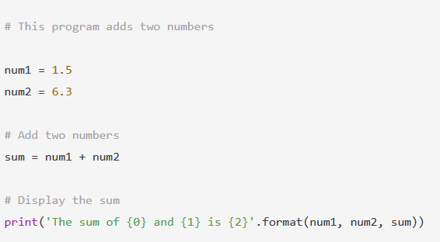 | 1

4. | Python | 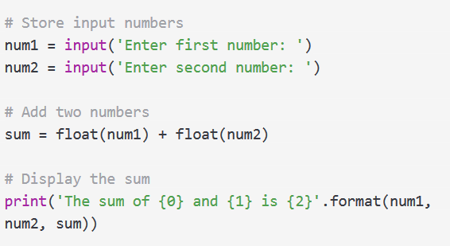 | 1
5. | Python | 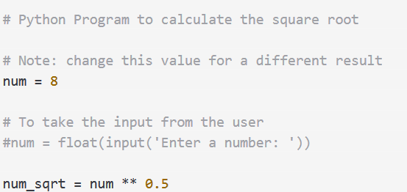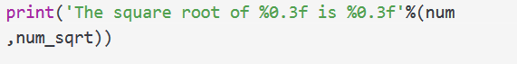 | 1

6. | 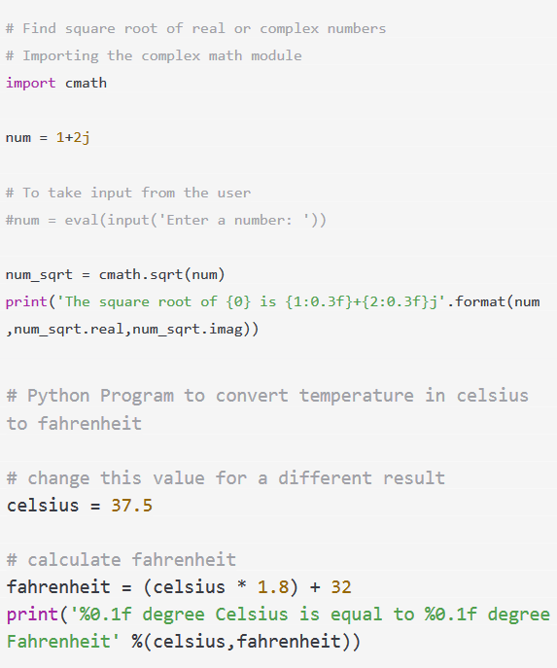  Python |  | 1
7. | Python |  | 1

8. | Python | 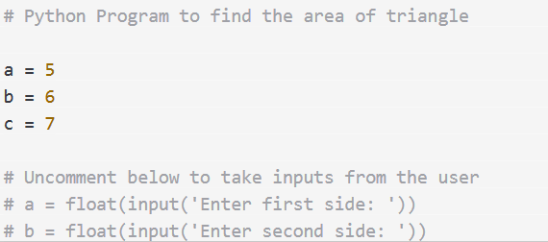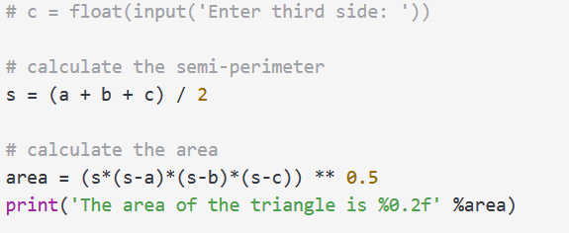 | 1

9. | Python | 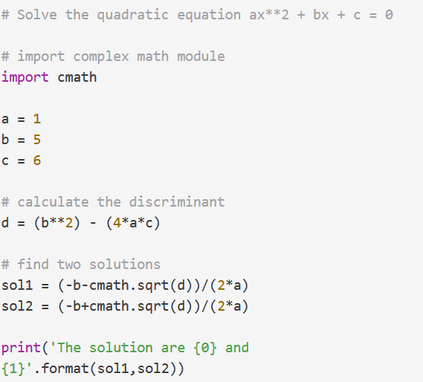 | 1
10. | Python | 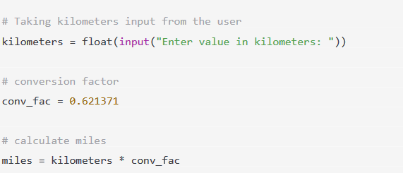 | 1
11. | Python | 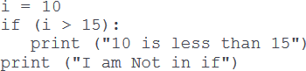 | 1

12. | 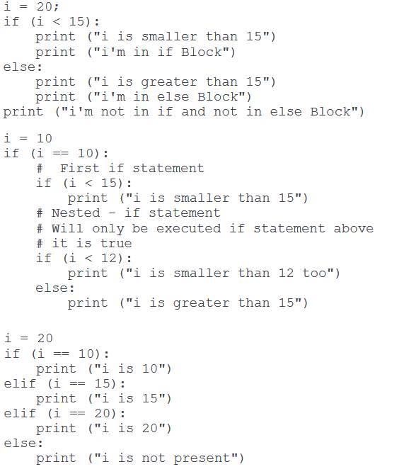  Python |  | 1
13. | Python |  | 1
14. | Python |  | 1
15. | Python | Exercise on for loops in Python: https://www.geeksforgeeks.org/python-for-loops/ | 1
16. | Python | Exercise on While loops in Python: https://www.geeksforgeeks.org/python-while-loops/ | 1
17. | Python | Exercise on Break statement in Python: https://www.geeksforgeeks.org/python-break-statement/ | 1
18. | Python | Exercise on Continue statement in Python: https://www.geeksforgeeks.org/python-continue-statement/ | 1
19. | Python | Exercise on various looping techniques in Python: https://www.geeksforgeeks.org/looping-techniques-python/ | 1
20. | Python | Exercise on User defined functions in Python: https://www.geeksforgeeks.org/functions-in-python/ | 2

21. | Python | Exercise on List data type in Python: https://www.programiz.com/python-programming/list | 1
22. | Python | Exercise on Tuple data type in Python:  https://www.programiz.com/python-programming/tuple | 1
23. | Python | Exercise on String data type in Python: https://www.programiz.com/python-programming/string | 1
24. | Python | Exercise on Set data type in Python:  https://www.programiz.com/python-programming/set | 1
25. | Python | Exercise on Dictionary data type in Python: https://www.programiz.com/python-programming/dictionary | 1
26. | Python | Exercise on Exception Handling in Python: https://www.programiz.com/python-programming/exception-handling | 2
27. | Python | Exercise on User defined Exception Handling in Python: https://www.programiz.com/python-programming/user-defined-exception | 2
28. | Numpy | Exercise on Numpy create Array Using Python: https://www.w3schools.com/python/numpy_creating_arrays.asp | 3,4
29. | Numpy | Exercise on Numpy Indexing in Array Using Python: https://www.w3schools.com/python/numpy_array_indexing.asp | 3,4
30. | Numpy | Exercise on Numpy Slicing in Array Using Python: https://www.w3schools.com/python/numpy_array_slicing.asp | 3,4
31. | Numpy | Exercise on Numpy Slicing in Array Using Python: https://www.w3schools.com/python/numpy_data_types.asp | 3,4
32. | Numpy | Exercise on Numpy Array coping and viewing : https://www.w3schools.com/python/numpy_copy_vs_view.asp | 3,4
33. | Numpy | Exercise on Numpy Array Shaping : https://www.w3schools.com/python/numpy_array_shape.asp | 3,4
34. | Numpy | Exercise on Numpy Array reshaping : https://www.w3schools.com/python/numpy_array_reshape.asp | 3,4
35. | Numpy | Exercise on Numpy Array iteration: https://www.w3schools.com/python/numpy_array_iterating.asp | 3,4
36. | Numpy | Exercise on Numpy Matrix joining  https://www.w3schools.com/python/numpy_array_join Week 4.asp | 3,4
37. | Numpy | Exercise on Numpy Array splitting https://www.w3schools.com/python/numpy_array_split.asp | 3,4
38. | Numpy | Exercise on Numpy Array searching https://www.w3schools.com/python/numpy_array_search.asp | 3,4
39. | Numpy | Exercise on Numpy Array sorting https://www.w3schools.com/python/numpy_array_sort.asp | 3,4
40. | Numpy | Exercise on Numpy Array Random technique https://www.w3schools.com/python/numpy_random.asp | 3,4
41. | Pandas | Exercise on Pandas basics: https://www.w3schools.com/python/pandas_tutorial.asp | 3,4
42. | Pandas | Exercise on Pandas installation: https://www.w3schools.com/python/pandas_getting_started.asp | 3,4
43. | Pandas | Exercise on Pandas Series data https://www.w3schools.com/python/pandas_series.asp | 3,4
44. | Pandas | Exercise on Pandas Data Frame: https://www.w3schools.com/python/pandas_dataframes.asp | 3,4
45. | Pandas | Exercise on Pandas Open CSV files: https://www.w3schools.com/python/pandas_csv.asp | 3,4

46. | Pandas | Exercise on Pandas Data analyzation: https://www.w3schools.com/python/pandas_analyzing.asp | 3,4
47. | Pandas | Exercise on Pandas Data Cleaning techniques:  https://www.w3schools.com/python/pandas_cleaning.asp | 3,4
48. | Pandas | Exercise on Pandas Data Correlation: https://www.w3schools.com/python/pandas_correlations.asp | 3,4
49. | Stats | Perform Mean, Midian and mode:  https://www.w3schools.com/python/python_ml_mean_median_mode.asp | 2
50. | Stats | Perform Standard Deviation: https://www.w3schools.com/python/python_ml_standard_deviation.asp | 2
51. | Machine  Learning | Implement Linear Regression  https://stackabuse.com/linear-regression-in-python-with-scikit-learn/ | 5
52. | Machine Learning | Perform Logistics Regression:  https://towardsdatascience.com/logistic-regression-using-python-sklearn-numpy-mnist- handwriting-recognition-matplotlib-a6b31e2b166a https://www.datacamp.com/community/tutorials/understanding-logistic-regression-  python | 5
53. | Machine  Learning | Exercise on Decision Tree: https://www.datacamp.com/community/tutorials/decision-tree-classification-python | 6
54. | Machine Learning | Exercise on SVM:  https://stackabuse.com/implementing-svm-and-kernel-svm-with-pythons-scikit-learn/ | 6
55. | Machine  Learning | Exercise on Time Series Analysis: https://www.dataquest.io/blog/tutorial-time-series-analysis-with-pandas | 6
56. | Machine Learning | Demonstration of Neural Networks: https://www.analyticsvidhya.com/blog/2020/07/neural-networks-from-scratch-in-python-  and-r | 7
57. | Deep  Learning | Exercise on MLP:  https://machinelearningmastery.com/neural-networks-crash-course/ | 7
58. | Deep Learning | Exercise on Feed Forward neural networks: https://builtin.com/data-science/feedforward-neural-network-intro | 7
59. | Deep Learning | Exercise on Neural Network:  https://www.analyticsvidhya.com/blog/2019/08/detailed-guide-7-loss-functions-machine- learning-python-code/ | 7
60. | Deep Learning | Exercise on Linguistics using Machine learning in python:  https://medium.com/towards-artificial-intelligence/natural-language-processing-nlp-with- python-tutorial-for-beginners-1f54e610a1a0 | 7
61. | Deep Learning | Text processing: https://pythonspot.com/category/nltk/ | 7
62. | Deep Learning | Text Analysis  https://medium.com/towards-artificial-intelligence/natural-language-processing-nlp-with- python-tutorial-for-beginners-1f54e610a1a0 | 7
63. | Deep Learning | Demonstrate Convolution Neural Network:  https://towardsdatascience.com/a-comprehensive-guide-to-convolutional-neural- networks-the-eli5-way-3bd2b1164a53 | 7
64. | Deep Learning | Perform CNN on CIFAR-10 Dataset  (https://www.analyticsvidhya.com/blog/2020/02/learn-image-classification-cnn- convolutional-neural-networks-3-datasets/) | 7
65. | Microsoft Azure | Microsoft Azure Video Lectures at Microsoft Learning | 10,  11,12

Annexure-II

SUGGESTIVE FORMAT AND SEQUENCE ORDER OF MOTIVATIONAL LECTURE.

Mentor
Mentors are provided an observation checklist form to evaluate and share their observational feedback on how students within each team engage and collaborate in a learning environment. The checklist is provided at two different points: Once towards the end of the course. The checklists are an opportunity for mentors to share their unique perspective on group dynamics based on various team activities, gameplay sessions, pitch preparation, and other sessions, giving insights on the nature of communication and teamwork taking place and how both learning outcomes and the student experience can be improved in the future.

Session- 1 (Communication):
Please find below an overview of the activities taking place Session plan that will support your delivery and an overview of this session’s activity.

Session- 1 OVERVIEW
Aims and Objectives:
- To introduce the communication skills and how it will work
- Get to know mentor and team - build rapport and develop a strong sense of a team
- Provide an introduction to communication skills
- Team to collaborate on an activity sheet developing their communication, teamwork, and problem-solving
- Gain an understanding of participants’ own communication skills rating at the start of the program

Activity: | Participant Time | Teacher Time | Mentor Time
Intro Attend and contribute to the scheduled.
Understand good communication skills and how it works.
Understand what good communication skills mean

Understand what skills are important for good
communication skills
Key learning outcomes: | Resources: |  | Enterprise skills developed:
- Understand the | - Podium |  | - Communication
communication | - Projector |  | - Self Confidence
skills and how it works.  - Understand what communication | - Computer  - Flip Chart  - Marker |  | - Teamwork
skills mean
- Understand what
skills are
important for
communication
skills

Schedule | Mentor Should do
Welcome: 5 min | Short welcome and ask the Mentor to introduce him/herself.  Provide a brief welcome to the qualification for the class.
Note for Instructor: Throughout this session, please
monitor the session to ensure nothing inappropriate is being happened.
Icebreaker: 10 min | Start your session by delivering an icebreaker, this will enable you and your team to start to build rapport and create a team presentation for the tasks ahead.  The icebreaker below should work well at introductions and encouraging communication, but feel free to use others if you think they are more appropriate. It is important to encourage young people to get to know each other and build strong team links during the first  hour; this will help to increase their motivation and communication throughout the sessions.

Introduction & Onboarding: 20mins | Provide a brief introduction of the qualification to the class and play the “Onboarding Video or Presentation”. In your introduction cover the following:  - Explanation of the program and structure.  - How you will use your communication skills in your professional life.  - Key contacts and key information – e.g. role of teacher, mentor, and SEED. Policies and procedures (user agreements and “contact us” section). Everyone to go to the Group Rules tab at the top of their screen, read out the rules, and ask everyone to verbally agree. Ensure that the consequences are clear for using the platform outside of hours. (9am-8pm)  - What is up next for the next 2 weeks ahead so young people know what to expect (see pages 5-7 for an overview of the challenge). Allow young people to ask any questions about the session topic.
Team Activity Planning: 30 minutes | MENTOR: Explain to the whole team that you will now be planning how to collaborate for the first and second collaborative Team Activities that will take place outside of the session. There will not be another session until the next session so this step is required because communicating and making decisions outside of a session requires a different strategy that must be agreed upon so that everyone knows what they are doing for this activity and how.  - “IDENTIFY ENTREPRENEURS” TEAM ACTIVITY  - “BRAINSTORMING SOCIAL PROBLEMS” TEAM ACTIVITY”  As a team, collaborate on a creative brainstorm on social problems in your community. Vote on the areas

you feel most passionate about as a team, then write down what change you would like to see happen.
Make sure the teams have the opportunity to talk about how they want to work as a team through the activities
e.g. when they want to complete the activities, how to communicate, the role of the project manager, etc. Make sure you allocate each young person a specific week that they are the project manager for the weekly activities and make a note of this.
Type up notes for their strategy if this is helpful - it can be included underneath the Team Contract.
Session Close: 5 minutes | MENTOR: Close the session with the opportunity for anyone to ask any remaining questions.  Instructor:  Facilitate the wrap-up of the session. A quick reminder of what is coming up next and when the next session will be.

Motivational Lectures Link

Topic | Speaker | Link
How to face Problems in life | Qasim Ali Shah Mr. Menk | https://www.youtube.com/watch?v=OrQte08Ml90  https://www.youtube.com/watch?v=jL28c7n2Wzo&pp=y gUPbWVuayBtb3RpdmF0aW9u
Just control your Emotions | Qasim Ali Shah  Mr. Menk | https://www.youtube.com/watch?v=JzFs yJt-w  https://www.youtube.com/watch?v=UDE52Cr3c3w
How to Communicate effectively | Qasim Ali Shah  Mr. Menk | https://www.youtube.com/watch?v=PhHAQEGehKc  https://www.youtube.com/watch?v=pK5bDFAjvpc
Your attitude is Everything | Tony Robbins  Mr. Menk | https://www.youtube.com/watch?v=5fS3rj6eIFg https://www.youtube.com/watch?v=9vxH7iWS100 https://www.youtube.com/watch?v=LJbRAK_Sp9E
Defeat fear, build Confidence | Shaykh Atif Ahmed  Mr. Menk | https://www.youtube.com/watch?v=s10dzfbozd4  https://www.youtube.com/watch?v=ifz4ni6Os0E https://www.youtube.com/watch?v=3MqN7Iptaj4
Wisdom of The eagle | Learn Kurooji | https://www.youtube.com/watch?v=bEU7V5rJTtw
The power of attitude | Titan Man | https://www.youtube.com/watch?v=r8LJ5X2ejqU
How to ace your exams | Mr. Zia | https://www.youtube.com/watch?v=F4pP4O-VPn0
Hopelessness | Mr. Ali | https://www.youtube.com/watch?v=yaVEqDU8Rkg

Annexure-III
Success Story

Success story is a source of motivation for the trainees and can be presented in several ways/forms in a NAVTTC skill development course as under: -
- To call a passed out successful trainee of the institute. He will narrate his success story to the trainees in his own words and meet trainees as well.
- To see and listen to a recorded video/clip (5 to 7 minutes) showing a successful trainee Audio-video recording that has to cover the above-mentioned points.*
- The teacher displays the picture of a successful trainee (name, trade, institute, organization, job, earning, etc) and narrates his/her story in the teacher’s own motivational words.

* The online success stories of renowned professional can also be obtained from Annex-II

Annexure-IV:
Workplace/Institute Ethics Guide

Work ethic is a standard of conduct and values for job performance. The modern definition of what constitutes good work ethics often varies. Different businesses have different expectations. Work ethic is a belief that hard work and diligence have a moral benefit and an inherent ability, virtue, or value to strengthen character and individual abilities. It is a set of values-centered on the importance of work and manifested by determination or desire to work hard.

The following ten work ethics are defined as essential for student success:

Attendance:
Be at work every day possible, plan your absences don’t abuse leave time. Be punctual every day.

Character:
Honesty is the single most important factor having a direct bearing on the final success of an individual, corporation, or product. Complete assigned tasks correctly and promptly. Look to improve your skills.

Team Work:
The ability to get along with others including those you don’t necessarily like. The ability to carry your weight and help others who are struggling. Recognize when to speak up with an idea and when to compromise by blend ideas together.

Appearance:
Dress for success set your best foot forward, personal hygiene, good manner, remember that the first impression of who you are can last a lifetime

Attitude:
Listen to suggestions and be positive, accept responsibility. If you make a mistake, admit it. Values workplace safety rules and precautions for personal and co-worker safety. Avoids unnecessary risks. Willing to learn new processes, systems, and procedures in light of changing responsibilities.

Productivity:
Do the work correctly, quality and timelines are prized. Get along with fellows, cooperation is the key to productivity. Help out whenever asked, do extra without being asked. Take pride in your work, do things the best you know-how. Eagerly focuses energy on accomplishing

Organizational Skills:
Make an effort to improve, learn ways to better yourself. Time management; utilize time and resources to get the most out of both. Take an appropriate approach to social interactions at work. Maintains focus on work responsibilities.

Communication:
Written communication, being able to correctly write reports and memos. Verbal communications, being able to communicate one on one or to a group.

Cooperation:
Follow institute rules and regulations, learn and follow expectations. Get along with fellows, cooperation is the key to productivity. Able to welcome and adapt to changing work situations and the application of new or different skills.

Respect:
Work hard, work to the best of your ability. Carry out orders, do what’s asked the first time. Show respect, accept, and acknowledge an individual’s talents and knowledge. Respects diversity in the workplace, including showing due respect for different perspectives, opinions, and suggestions.

Artificial Intelligence Machine Learning Deep Learning

